Individual Number (My Number) Report Form

Date submitted (yyyy/mm/dd):
Staff/Student ID No. |  |  |  |  |  |  |  |  |  | Name
Affiliation
(School, department, division, etc.)
 |  |  |  |  |  |  |  |  |  | Date of birth | / /
 |  |  |  |  |  |  |  |  |  |  | (yyyy/mm/dd)
Employment  start date | / / |  |  |  |  |  |  |  |  | Email
 | (yyyy/mm/dd)

I hereby submit the documents specified in 1 or 2 below to report my Individual Number.

- A copy of Individual Number Card (both sides)
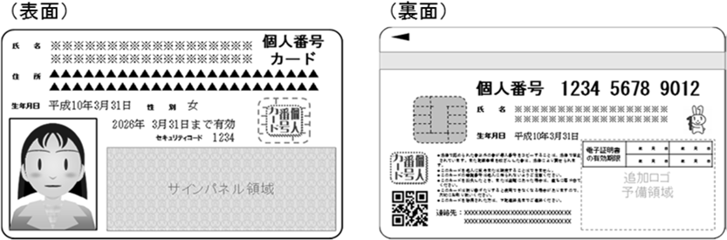
Front
Back
Please provide a copy of both sides of your card to verify your Individual Number and identity. No identification documents listed in 2 below are required if you submit a copy of both sides.
Individual Number

- A copy of Individual Number Notification Card/certificate of residence with identification document(s)
A copy of Individual Number Notification Card  （個人番号通知カード）  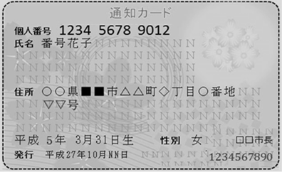  Individual Number |  | Or | A copy of certificate of residence showing your Individual Number  Example of certificate of residence  Individual Number  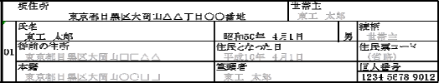  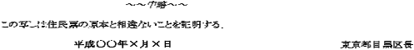
Note: The Individual Number Notification Card was replaced by the Individual Number Notification Letter (個人番号通知書) on May 25, 2020 and is no longer being issued. If you only received a Notification Letter from your municipality, please provide a copy of your Individual Number Card or certificate of residence for verification.
The above document must be accompanied by a copy of the identification document(s) below.
One of the following photo IDs |  | Or | Two of the following non-photo IDs
- Passport  - Residence card  - Special Permanent Resident Certificate  - Driver’s license  - Driving history certificate | - Student ID (with photo and date of birth)  - Basic Resident Registration Card (with photo)  - Disability certificate |  | - Health insurance card  - Certificate of residence  - Withholding tax statement  - Pension book  - Family register  - Receipt of tax or utility payment | - Basic Resident Registration Card (without photo)  - Certificate of Child Rearing or Special Child Rearing allowance  - Certificate of seal impression
Tokyo Tech staff ID is not acceptable as it shows neither address or date of birth.
- - - - - - - - - - - - - - - - - - - - - - 【For Office Use Only】 - - - - - - - - - - - - - - - - - - - - - -
■マイナンバー確認 下記のいずれか一つの書類でマイナンバー確認が可能
□個人番号カード □通知カード □マイナンバーの記載されている住民票
■身元確認
下記のいずれか一つの身元確認書類（顔写真付き身分証明書）で身元確認が可能
□個人番号カード □運転免許証 □パスポート □運転経歴証明書
□障がい者手帳 □療育手帳 □在留カード □特別永住者証明書
□住民基本台帳カード（写真付） □学生証（写真付きで生年月日等が確認可能なら本学以外のものも可）
下記のいずれか二つの身元確認書類（顔写真無し身分証明書）で身元確認が可能
□国民健康保険被保険者証 □健康保険被保険者証 □国家公務員共済組合員証
□国民年金手帳 □児童扶養手当証書 □特別児童扶養手当証書
□印鑑登録証明書 □戸籍の附票 □住民票
□源泉徴収票 □国税，地方税，社会保険料，公共料金の領収書
□住民基本台帳カード（写真なし）
■書類内容のチェック
□本人確認 （本人からの提出か） □氏名確認（マイナンバー確認書類と身元確認書類の氏名は同一か）
□生年月日または住所確認 （マイナンバー確認書類と身元確認書類の生年月日又は住所は同一か
受 領 印

